Education Authority - Southern Region
St. Paul’s Primary School

Principal: Mr Niall Geoghegan  Tel/Fax: (028) 40630145 | 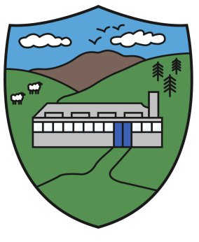 | 35 Ballykeel Road,  Cabra,  Newry,  BT34 5RH
“Let your light shine, be the best you can be”

2nd May 2024

Dear Parents,
CONFIRMATION DAY - Friday 10th May
The Confirmation ceremony will take place on Friday 10th May in St. Mary’s Cabra at 2:00pm.

Information:
- As the ceremony will take place at 2:00pm, the pupils from P4-P6 who form the choir will go via bus from the school to the chapel at 1:15pm.
- Pupils in the choir need to be picked up at 3:00pm from the chapel yard.
- Pupils from P1-P3 will remain in school as normal and finish at the normal time. If there are any siblings of the Confirmandi that need collected to go to the ceremony, please collect them by 1:00pm.
- Bus for P1-P3 children will still be available on Friday at its normal time of 2:00pm.

Yours faithfully

____________
Niall Geoghegan
Principal

