TUE 16-01-24

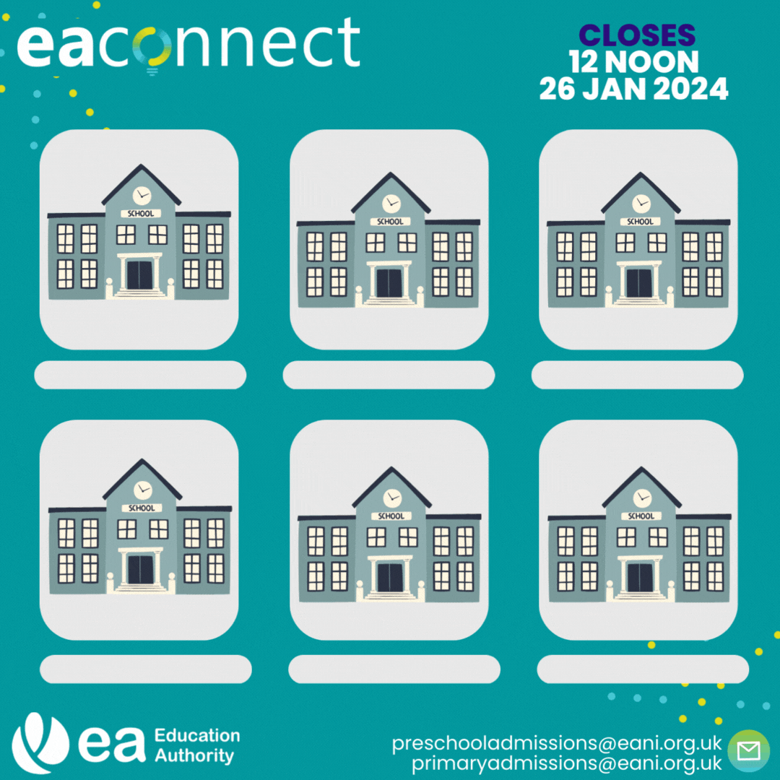

Online applications for Pre-School and Primary 1 for September 2024 are currently open! You can apply now via EA Connect: https://connect.eani.org.uk/parent/
EA recommends that you list at least four pre-schools or primary schools in the order of your preference. Make sure you read carefully through the published admissions criteria for the pre-school settings and schools you are considering before submitting your application.
For more information on the application process, visit: www.eani.org.uk/admissions #EAadmissions

